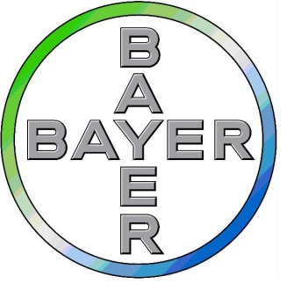****

**Application for the BIR/Bayer AI Fellowship 2025**

This scheme is for an early-career professional (trainee radiologist, consultant radiologist, medical physicist, radiographer or other professional) within three years of qualifying to spend one week with Bayer. **The Fellowship is open to BIR members only.**

Bayer will fund accommodation and travel costs for the successful candidate.

The successful candidate will be required to present their experience, findings and ideas at a relevant BIR event or host a webinar or write a blog, as agreed by the BIR.

**Your application must be accompanied by a current CV.**

**Details of Applicant**:

|  |  |
| --- | --- |
| Title and Surname: | |
| Other Names: | |
| Please confirm you are a member of the BIR | |
| Email Address: | |
| Telephone number (mobile) | |
| Current Post: | |
| Name of Employer/Training Scheme/Hospital: | |
| Address: | |
|  | |
| City: | Postcode: |

**Personal Statement**

|  |
| --- |
| **Please provide a statement (no more than 750 words) explaining why you are applying for the fellowship and what you hope to gain from the experience should you be successful.** |

**Signature by applicant:**

……………………………………………………………Date…………………………………………………

Please email completed form and any relevant supporting attachments to: [awards@bir.org.uk](mailto:awards@bir.org.uk)

Or post to: Ms Lucy Stewart, BIR, Audrey House, 16-20 Ely Place, London EC1N 6SN

Closing date for applications: 30 April 2025

**NB: Application forms available online:** [**BIR AI Fellowship**](https://bir.org.uk/get-involved/prizes,-awards-and-bursaries/bir-artificial-intelligence-fellowship.aspx)