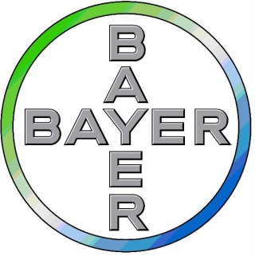



**Application for the BIR/Bayer Make it Better Service Award**

Applications **MUST** demonstrate that the delivery of a particular service or patient experience has improved. This may be by reducing cost, increasing throughput, by improving diagnostic quality leading to better outcomes, better infection control, higher staff or patient satisfaction or has improved comfort, or reduced motion of the patient as examples. This list is not exhaustive but is given as examples.

**Details of Applicant(s)**: Please fill in full details of the lead applicant and provide the names of any other contributors below:

**Lead Applicant:**

|  |  |
| --- | --- |
| Title and Surname: | |
| Other Names: | |
| Email Address: | |
| Telephone number (mobile) | |
| Current Post: | |
| Name of Employer/Training Scheme/Hospital: | |
| Address: | |
|  | |
| City: | Postcode: |

**Other Contributors:**

|  |
| --- |
| Name: |
| Name: |
| Name: |
| Name: |
| Name: |
| Name: |
| Name: |

**Details of improvement in service/patient experience:**

|  |
| --- |
| Aim of improvement in one sentence: |
| Summary and background (no more than 750 words): |
| Where was the improvement carried out? |
| How was the need identified? |
| What was developed to improve the service delivery or patient experience? |
| What resources were used to carry out the improvement? |
| What method did you use to evaluate the success of the improvement? |
| Evidence of success via feedback from patients and/or staff |

**Signature by applicant:** ……………………………………………………………Date…………………………………………………

Please email completed form and any relevant supporting attachments to: [awards@bir.org.uk](mailto:awards@bir.org.uk)

Or post to: Ms Lucy Stewart, BIR, Audrey House, 16-20 Ely Place, London EC1N 6SN

Closing date for applications: 31 May 2025

**NB: Application forms available online:** [**http://www.bir.org.uk/makeitbetterserviceaward**](http://www.bir.org.uk/makeitbetterserviceaward)